Overall, the feedback shows that people found the page easy to understand and thought it looked clean and professional, with all users rating their experience as good or excellent. The title and description both helped explain what the page was for, and most labels and required fields were clear without causing confusion. The appointment date and reason-for-visit fields also made sense to users, and the “Book Appointment” button clearly showed what would happen when clicked. The only real improvement mentioned was making the font easier to read. This suggests that the core structure of the page works well, but the design could be slightly improved to make it even more visually comfortable.
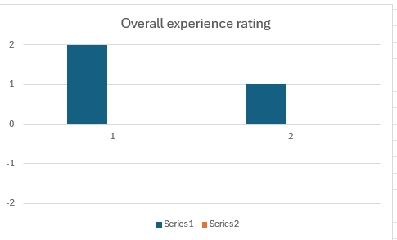
Based on the results of the questionnaire the questions I used were clear for the user filling it out with no problems or confusion making the questions effective to evaluate upon.

